**8. You have a Cisco switch and a VoIP phone that needs to be placed in a voice VLAN (VLAN 20). The data for the PC should remain in a separate VLAN (VLAN 10). Configure the switch port to support both voice and data traffic.**

**Setting Up:**

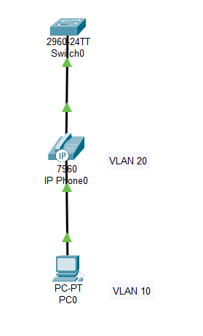

**Configuring the switch:**

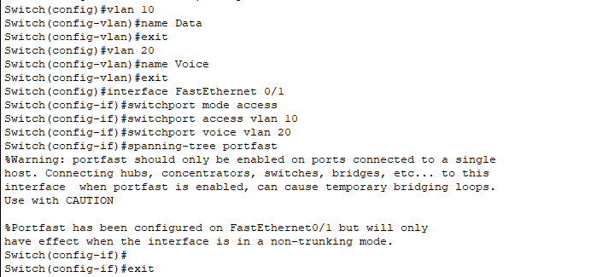

**Switch Support both Voice and data traffic:**

